Mini-Project for EG7023 Radio Communications

Student: Yan Fei
Tutor: Dr. David Siddle

I declare that this assignment is my own work, that sources of reference are acknowledged and that it has not been submitted for any other course. I understand that plagiarism is a serious offence under the University’s regulations and that appropriate penalties will be applied if I am found to have submitted plagiarism work.

Contents
Design of the Mobile Telephone System 1
Requirements for the Mobile Telephone System in Rome 1
Preparation for the Mobile Telephone System 1
Calculation for the Mobile Telephone System 2
Distribution of the Antennas 4
Implement for the Mobile Telephone System 7
The Mobile Telephone System for Original Design 7
Setting Parameters 7
Analysing Results 7
Conclusion 14
Improving the Signal Power by Changing the Location, Height of Antenna and Adding More Antennas 15
Setting Parameters 15
Analysing Results 16
Conclusion 19
Improving the Co-Channel Interference by Changing the Locations and Height of Antennas 20
Setting Parameters 20
Analysing Results 20
Conclusion 23
Improving the System to Minimise the Co-channel Interference 24
Setting Parameters 24
Analysing Results 24
Conclusion 27
Discussion 28
Fading 28
Co-channel Interference 28
Conclusion 29
References 30

Design of the Mobile Telephone System
In the project, we want to set up the mobile telephone system for the city of Rome, the requirements of the system are as below:

Requirements for the Mobile Telephone System in Rome
- Estimation of traffic. We have a license for up to 600 channels.
- The blocking factor should be no more than 2%.
- Co-channel interference should be considered.
- We assume that in order for the mobile unit to receive a call the signal power should be higher than -85dBm.
- We should investigate the effect of signal fading in the above calculation.
- The height of mobile units may be taken as 1.5m.
- The frequency of transmission is 1.8GHz.
- We should minimise the base station power.
- No base station antenna can be placed more than 4m above the skyline.
- We just are responsible for a subarea with sides of between 1.5 and 2km.

Preparation for the Mobile Telephone System
After knowing the requirement for the system, firstly, we should consider the population and population density in Rome in order to provide the good service that keeps all the clients can use the system as well as possible.
Through some investigation, we find the population condition in Rome for 2006 on the website:
http://www.citymayors.com/statistics/largest-cities-density-125.html
Largest cities in the world ranked by population density
Rank | City / Urban area | Country | Population | Land area  (in sqKm) | Density  (people per sqKm)
77 | Goiania | Brazil | 1,475,000 | 479 | 3,100
78 | Munich | Germany | 1,600,000 | 518 | 3,100
79 | Stuttgart | Germany | 1,250,000 | 414 | 3,000
80 | Dublin | Ireland | 1,075,000 | 365 | 2,950
81 | Kuwait | Kuwait | 1,600,000 | 544 | 2,950
82 | Nizhni Novgorod | Russia | 1,500,000 | 505 | 2,950
83 | Rome | Italy | 2,500,000 | 842 | 2,950
84 | Phnom Phen | Cambodia | 1,500,000 | 518 | 2,900
85 | Beirut | Lebanon | 1,800,000 | 648 | 2,800
86 | Brasilia | Brazil | 1,625,000 | 583 | 2,800
87 | Essen/Düsseldorf | Germany | 7,350,000 | 2,642 | 2,800

Comparing with the data from other database, we think the population density 2950p/km² in Rome is the reasonable one. So we use this as the population density for the further calculation of the Mobile Telephone System.
In this system, I want to use the seven-cell cluster which can be described as the graph below:
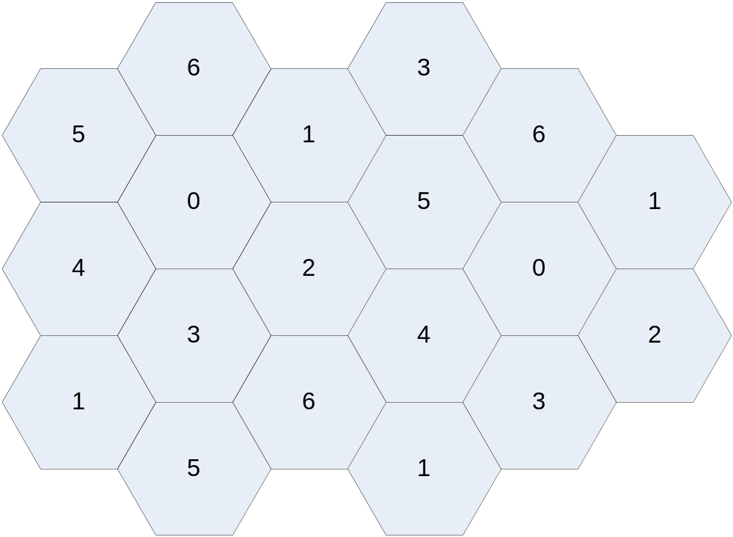
The reason I use this frequency reuse-pattern is that for the fixed number of channels, population density and area, the size of the cell and the available channels in the cell is the most reasonable choice for the system. The 12-cell cluster which could reduce the co-channel interference (20.7dB) will reduce the available channels in each cell and the size of the cell. It means that we will need more base station in the area. That will increase our cost for the system.

Calculation for the Mobile Telephone System
The last thing we should do before implementing the system is that we should calculate the size of the cell through the preparations above.
From the Erlang B values table the offered traffic with 85 available channels (cell) for a blocking probability of 0.02 is
The carried traffic is
We assume that the each user makes an average of 3 calls/hour, each call lasts an average of 3 minutes. So the traffic intensity by each user is
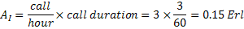
Therefore, the maximum number of users that can be supported by this cell is:
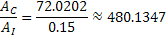
Because the population density is about 3000p/km², the cell size will be
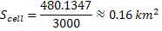
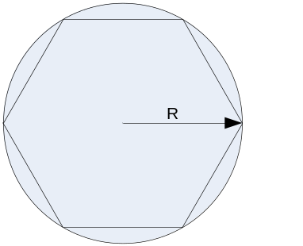
So the radius is

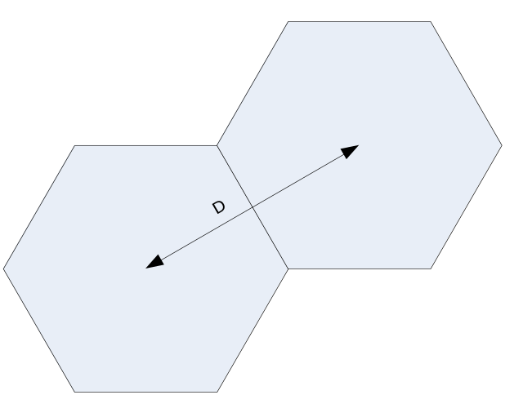
The distance between two cells is

Distribution of the Antennas
I choose the region (51420<x<51600, 5033800<y<5035800) as the area where I should allocate the antennas in.
Firstly, I allocate the antennas and channels as following graph:
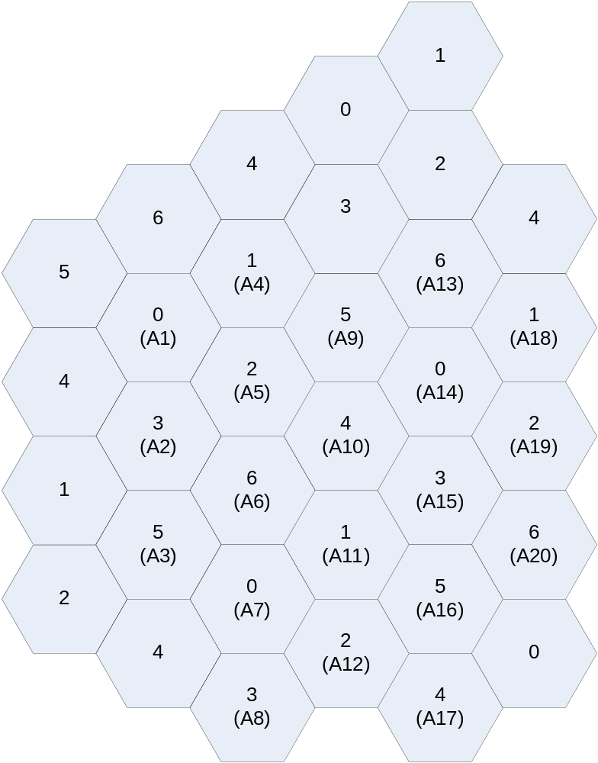
We can see that there are 20 antennas in this area which use 7-cell cluster frequency reuse pattern.
After this, I set the first antenna with the location(x=514465.52, y=5035398.64) and carrier as 0.Then I can calculate all the locations of other antennas and carriers. The data is as below:
Antenna | X | Y | Carrier
A1 | 514465.52 | 5035398.64 | 0
A2 | 514465.52 | 5035007.74 | 3
A3 | 514465.52 | 5034616.84 | 5
A4 | 514803.04 | 5035593.87 | 1
A5 | 514803.04 | 5035203.07 | 2
A6 | 514803.04 | 5034812.17 | 6
A7 | 514803.04 | 5034421.27 | 0
A8 | 514803.04 | 5034030.37 | 3
A9 | 515142.62 | 5035398.64 | 5
A10 | 515142.62 | 5035008.54 | 4
A11 | 515142.64 | 5034618.44 | 1
A12 | 515142.64 | 5034227.54 | 2
A13 | 515480.14 | 5035593.94 | 6
A14 | 515480.14 | 5035203.04 | 0
A15 | 515480.14 | 5034812.14 | 3
A16 | 515480.14 | 5034421.24 | 5
A17 | 515480.14 | 5034030.34 | 4
A18 | 515819.72 | 5035398.64 | 1
A19 | 515819.72 | 5035007.74 | 2
A20 | 515819.72 | 5034616.84 | 5

Hereto, we have finished the calculation for the mobile telephone system. Then we will use winprop software to test this system we design.

Implement for the Mobile Telephone System

The Mobile Telephone System for Original Design

Setting Parameters
In the winprop, we use the default antenna power 10w. The prediction height is 1.5m and frequency is 1800MHz. All the heights of the antennas are set up as the tallest buildings nearby with 4m high. Because in this step, we just set all the parameter as the data we calculate above, there may be something unsuitable, and we will improve it later.

Analysing Results
Through the propagation project, we calculate the data from each of the 20 antennas and put the data into the network project. Then we get the output result of Best Server, Cell Area, CoChannel Interference, Maximum Power and Nr Received Channels from the original design.
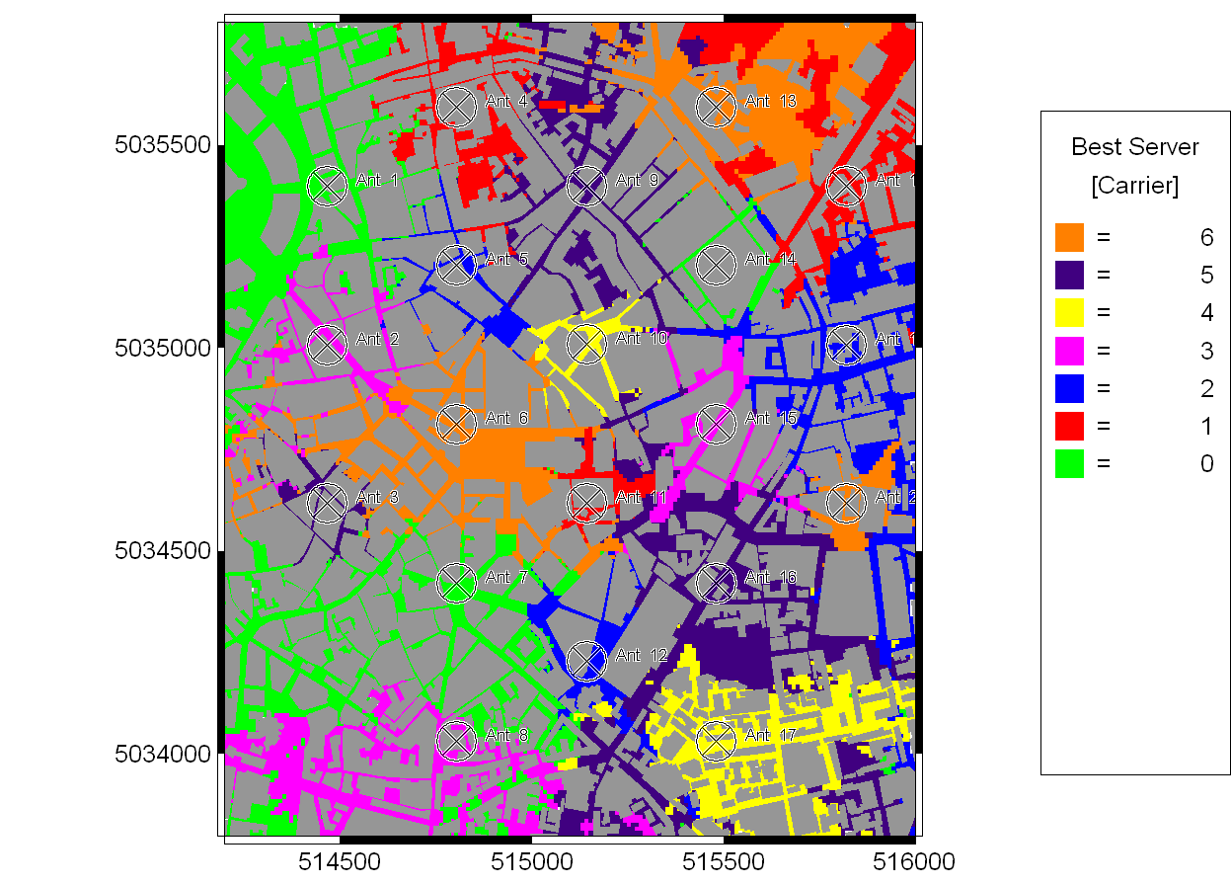
We can see that the best carrier for each pixel in the graph is almost as the carrier of the closest antenna. The areas with same carriers are separated by the areas which use different carriers. That will reduce the co-channel interference.
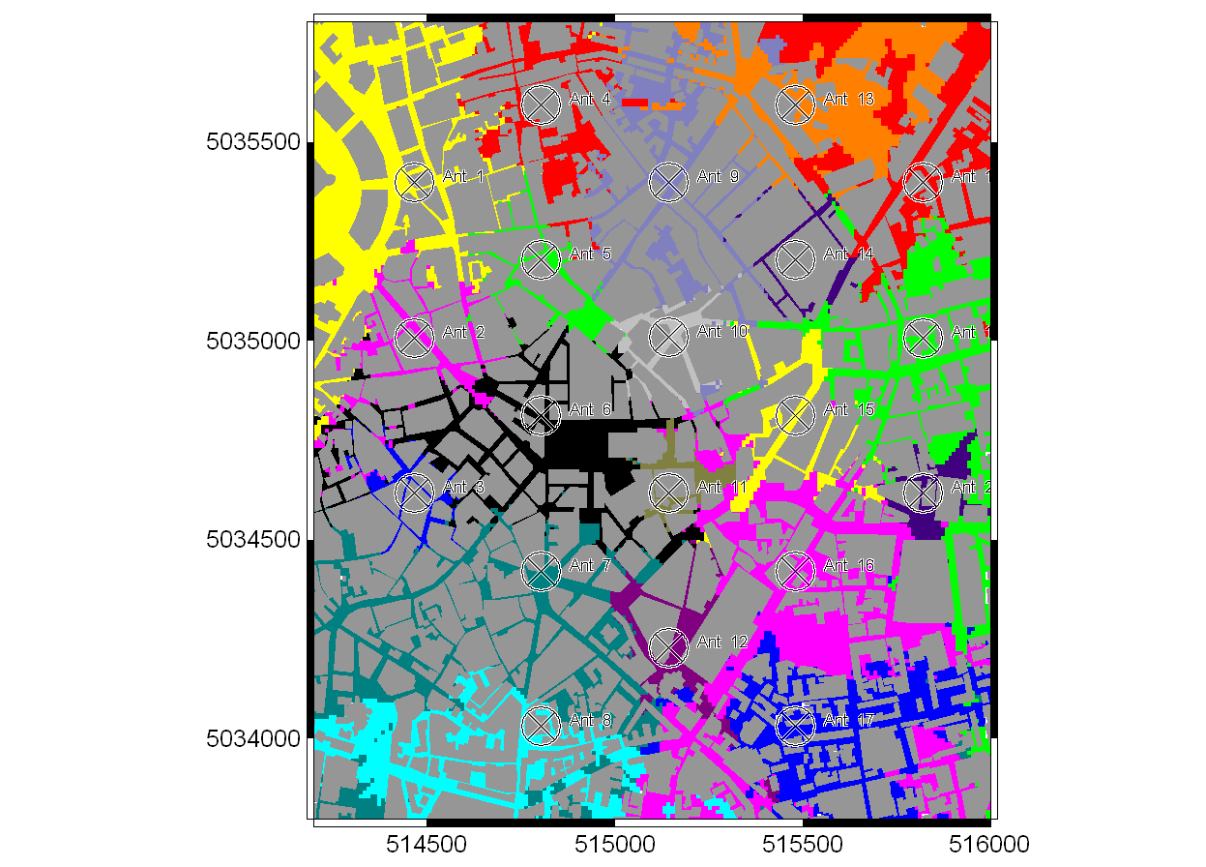
This is the cell area graph which indicates coverage of each cell. This picture is similar to the best server graph. We can see that each cell cover different areas with different sizes.
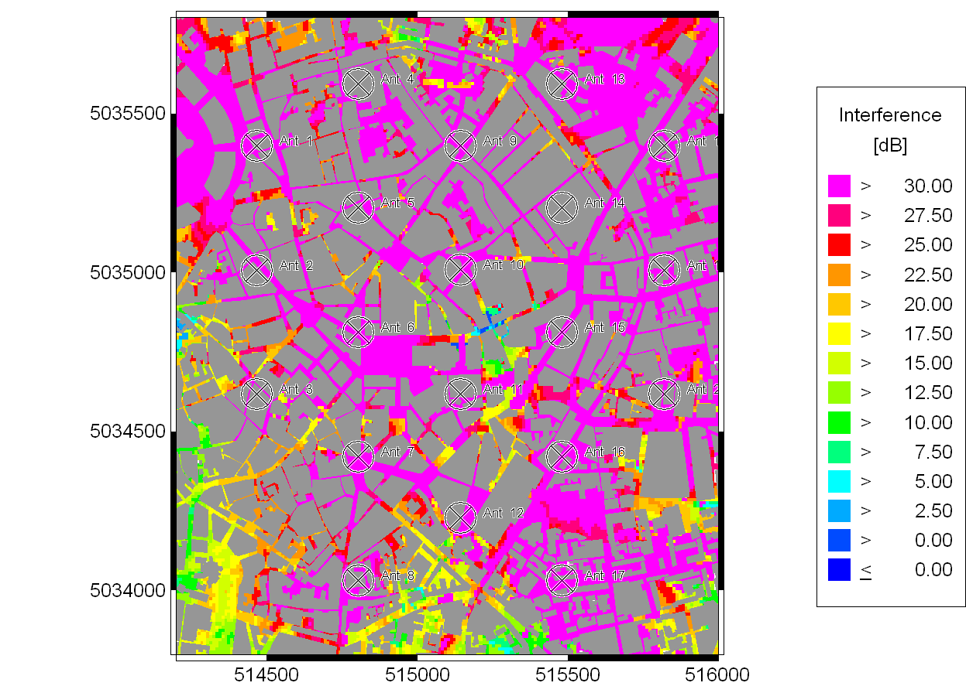
This is the output data of co-channel interference. From the figure above, we can see that the interference of every location is almost above the threshold and most of them overpass 30dB. There just a small area in the centre of the graph with serious interference. So we will improve it later.

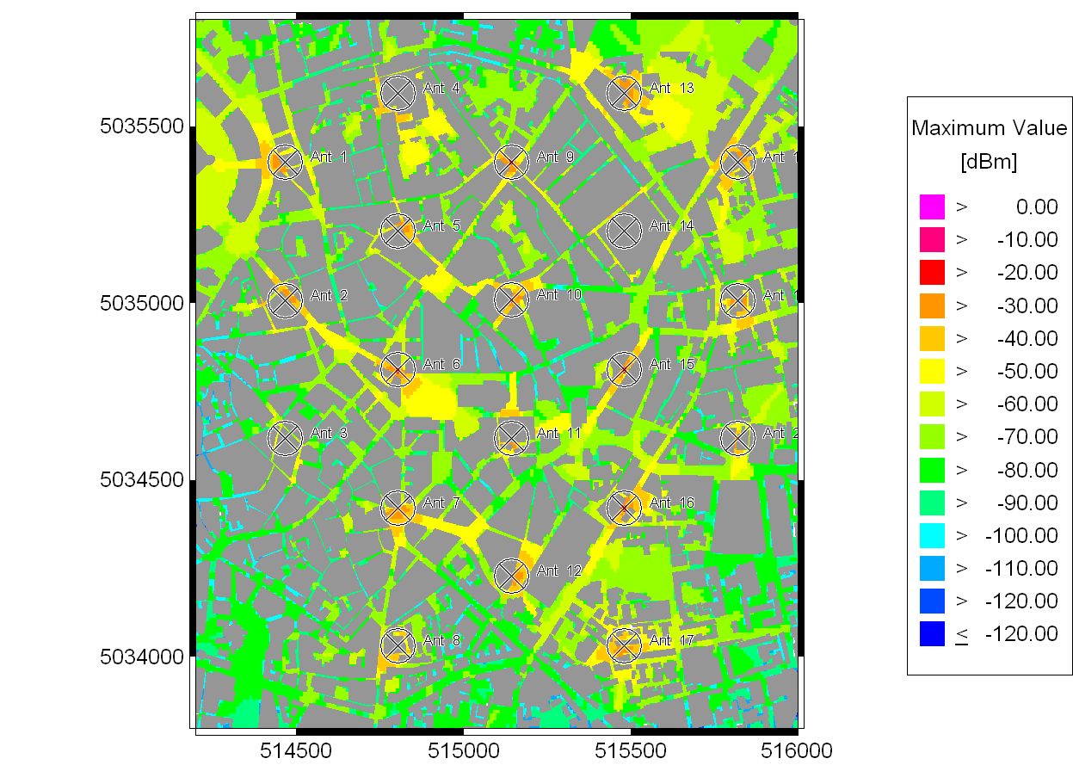
From this figure, we can see that the signal power in most area is bigger than the -85dB.It means that the clients can get the signal and make a call in most area within this region. So the power 10w we use in antennas is enough for this system.

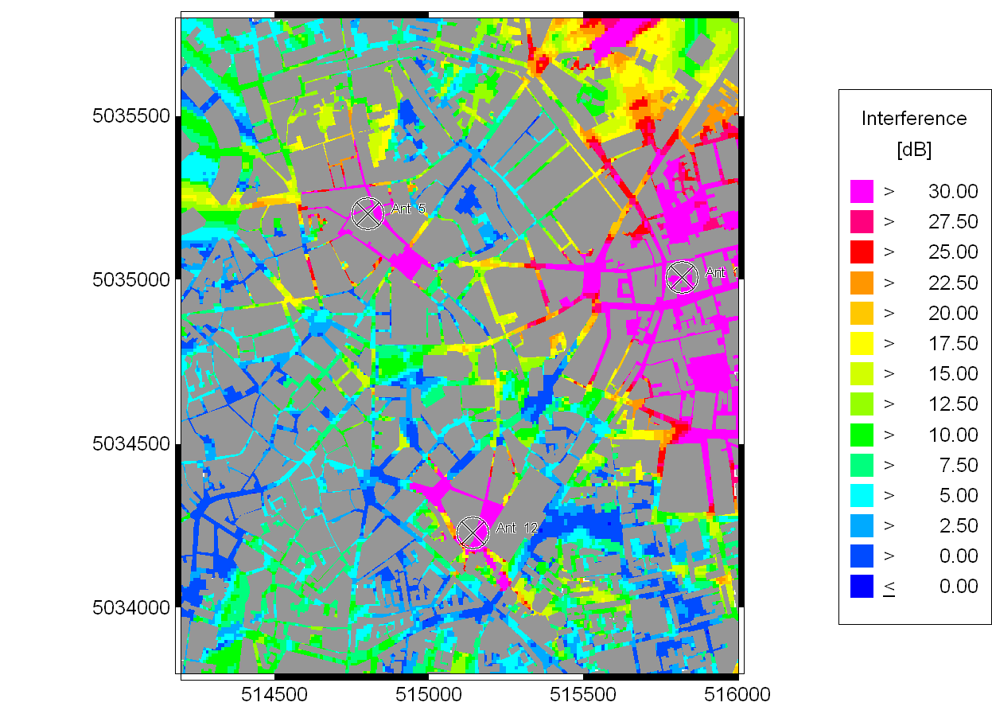
The picture shows that the co-channel interference of same carrier (2) with antenna 5, 12 and 19. We can see that the interference condition is much good due to the 7-sell cluster for frequency reuse pattern.
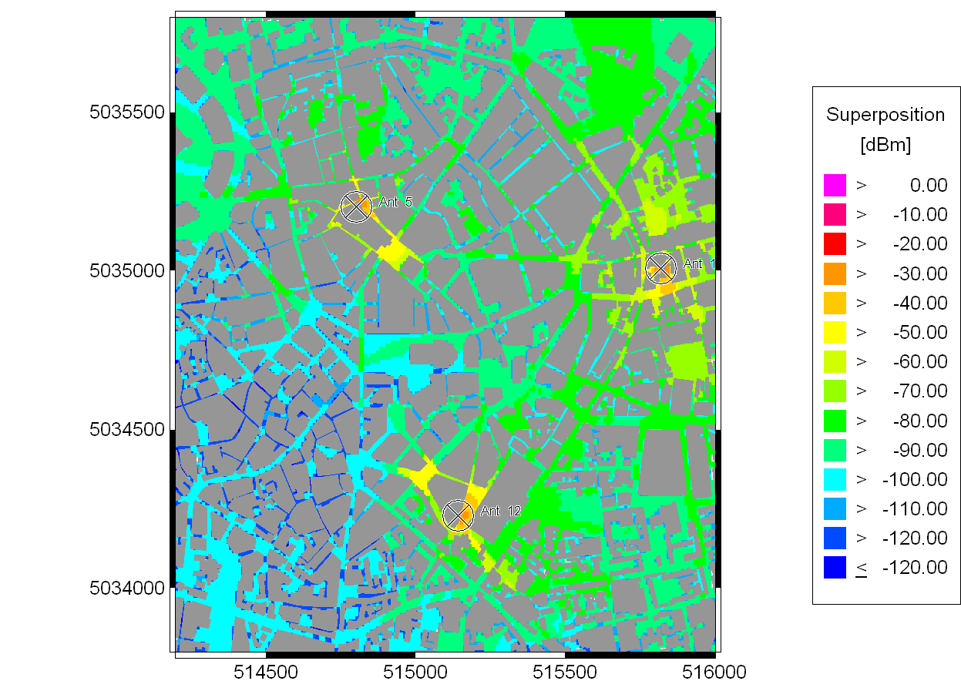 This figure illustrates the power distributions for the antenna 5, 12 and 19. We can see that the power condition is good under these antennas with the carrier 2.
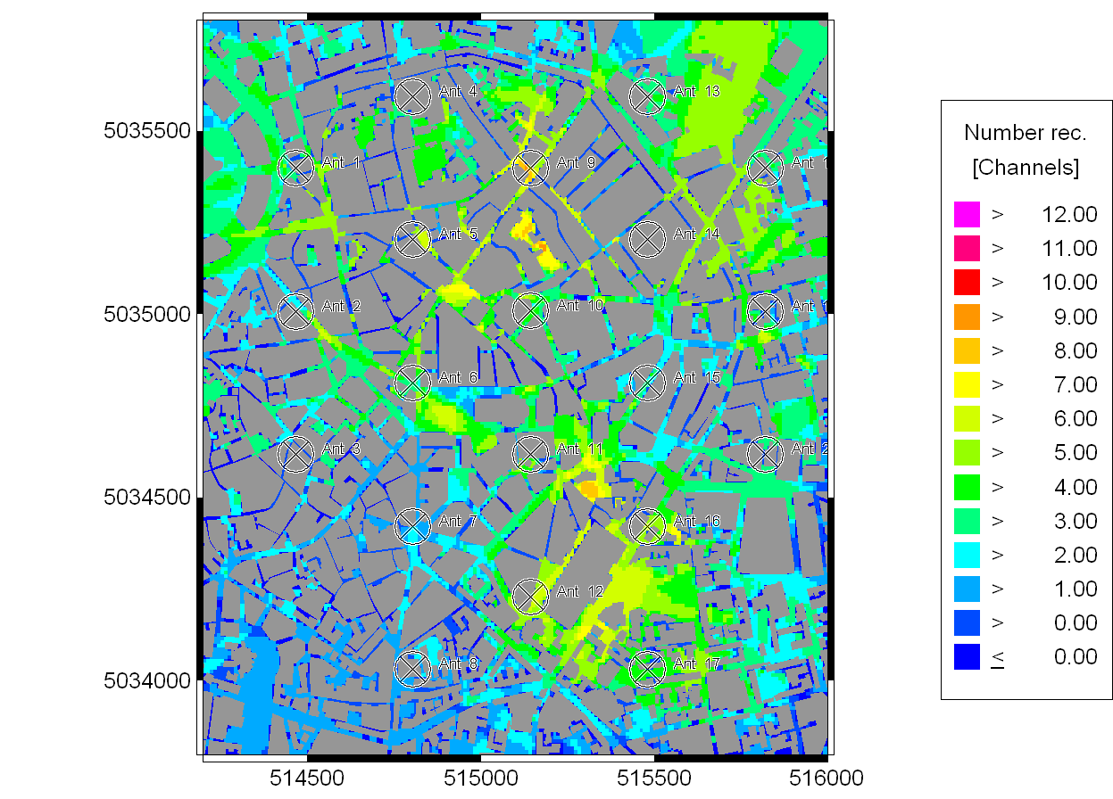
This figure shows that how many channels are available in each pixel. We have set the threshold as -85dB. We can see that there are some areas can receive more than one channel. That means the signal power with different carriers from different antennas is higher in these regions. So clients in these areas will have more channels to choose. For instance, if the signal quality is decreased by people’s move, the system can switch the client to use other channels which have better signal quality. This will avoid the disconnection of the call. There also some areas which cannot get channels at all, but these areas are not too large and we can improve it by some methods which we will do later. Some specific areas which still cannot get the channels could be neglected.
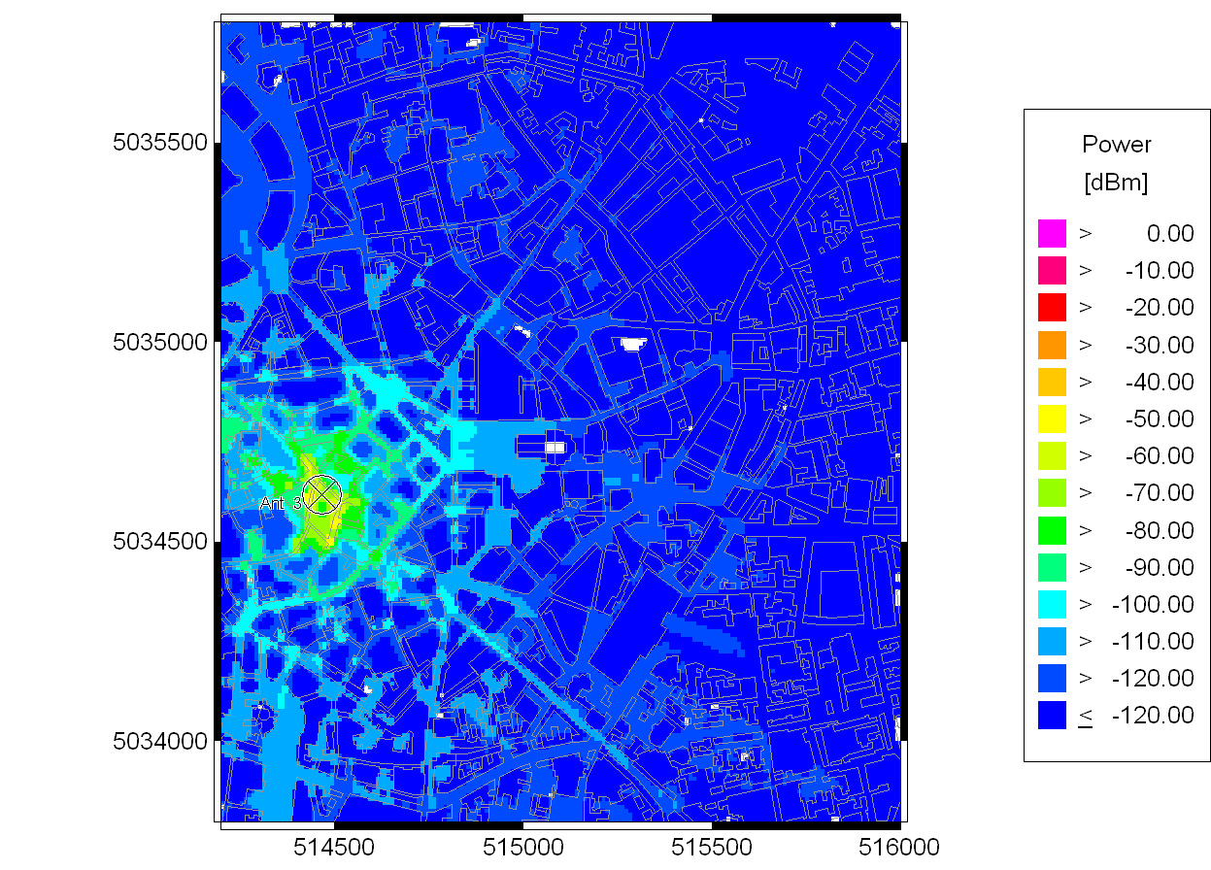
This is the picture showing the power distribution of the antenna 3, which we want to use to compare the power condition between outdoor and indoor. We can see that the areas closer to the antenna have good power condition and the outdoor power is 30-50dB higher than indoor’s.

Conclusion
Through the result above, we can see the system we design is fairly good for use. However, we can see that there are some areas which can not fit for the situation for mobile communications. Thus, we will try to improve the system by adding more antennas, moving the location of the antenna, increasing the height of the antenna to increase the signal power and reduce the co-channel interference.

Improving the Signal Power by Changing the Location, Height of Antenna and Adding More Antennas

Setting Parameters
In this improving procedure, we try to improve signal power distribution by moving the antenna, increasing the height of the antenna and adding one antenna.
I find the power distribution of antenna 3 is not good, so I move the antenna 3 to the location (x=514426.71, y=5034616.55) and increase the height of it from 16m to 24m.
Because the signal quality is poor in the left down area, I decide to add one antenna to improve it.
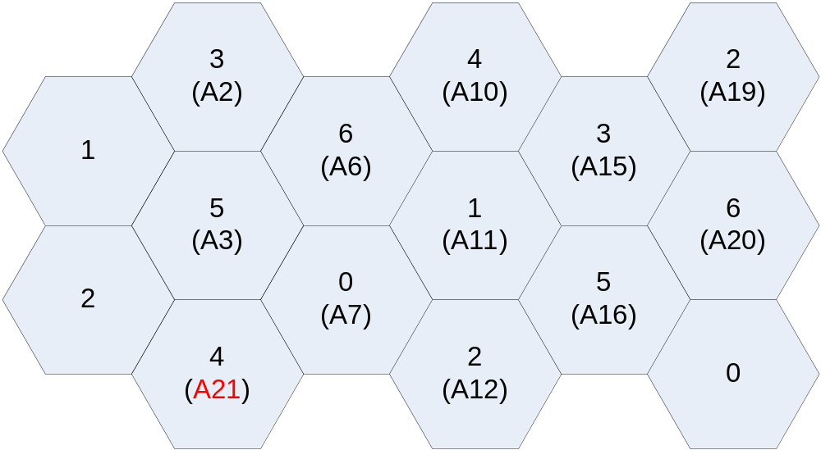

Antenna | X | Y | Carrier
A21 | 514465.52 | 5034225.94 | 4

Analysing Results
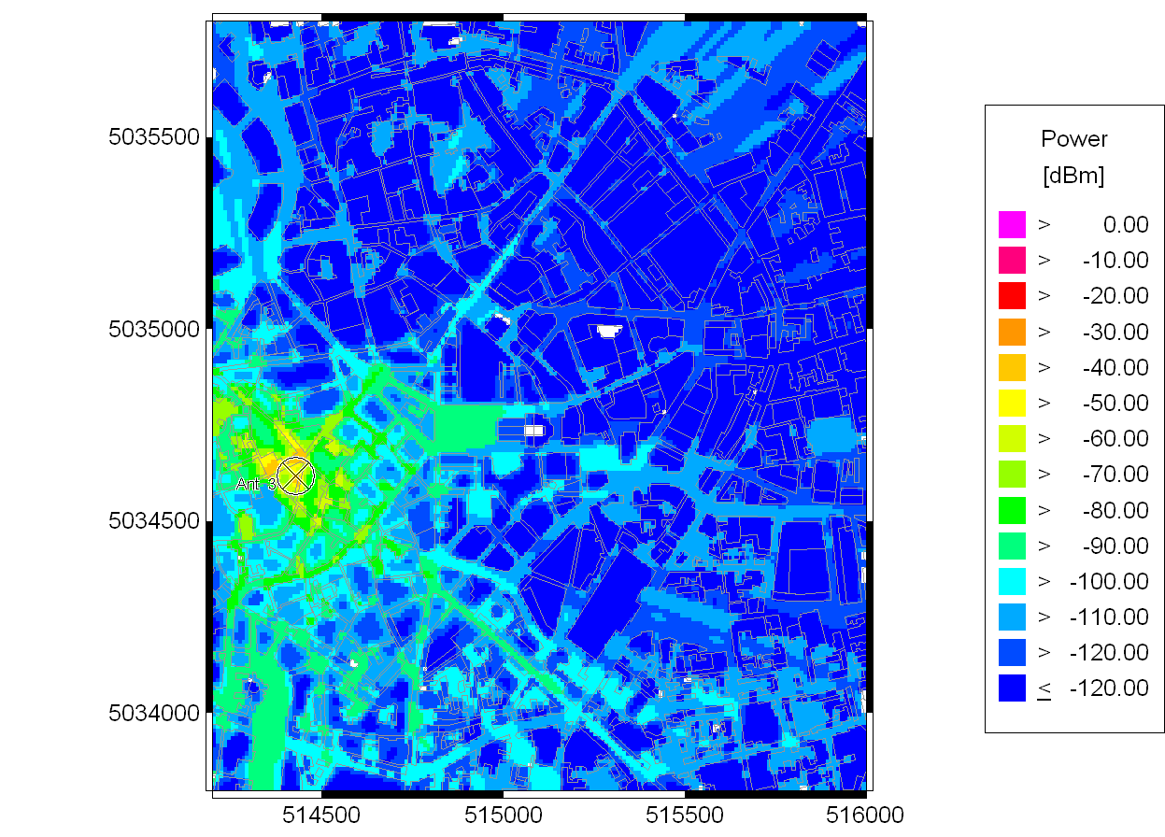
This is the graph showing the power distribution of antenna 3, which is better than that before.
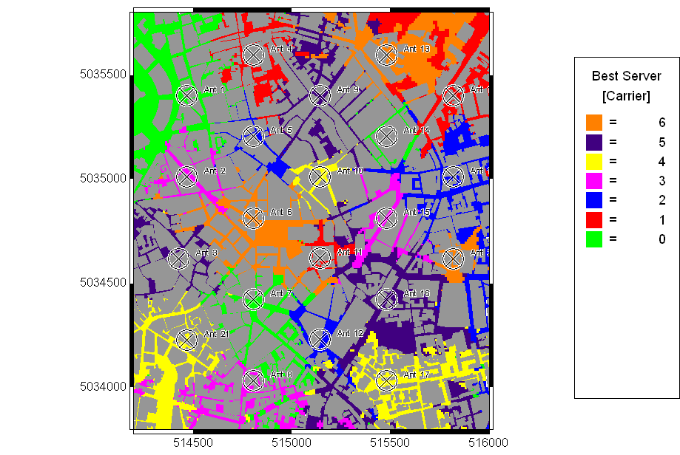
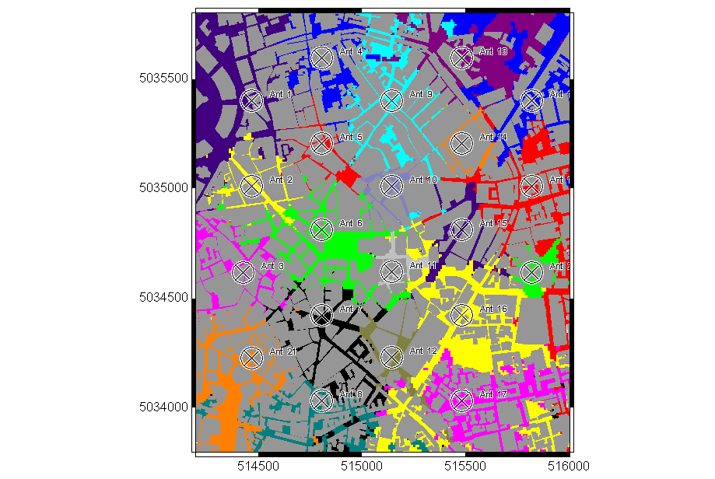
These two graphs indicate that the coverage of the cell using antenna 3 is increased and the coverage of the cells using antenna 7 and 8 are decreased. The most decreased areas are belong to the cell using antenna 21 now.
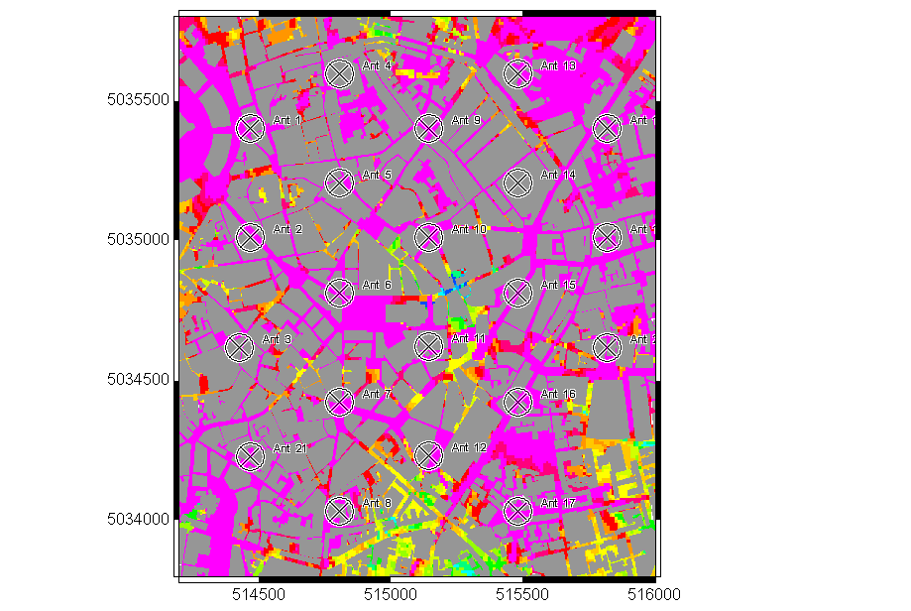
After adding the antenna 21, we can see that the co-channel interference in the left down areas is getter better comparing with the previous one.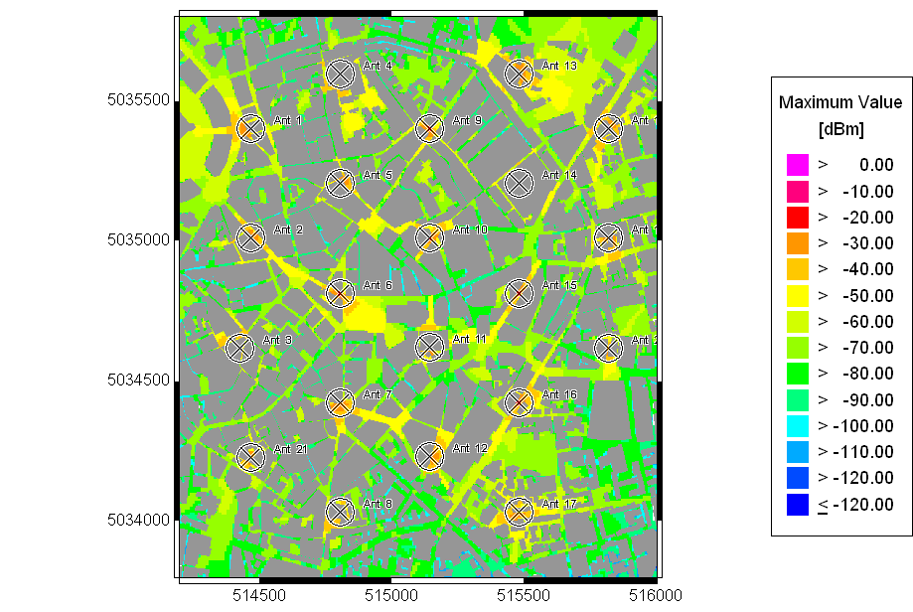

After adding the antenna 21 and moving antenna 3, we can find the signal power increases 10-20dBm in the left down areas.
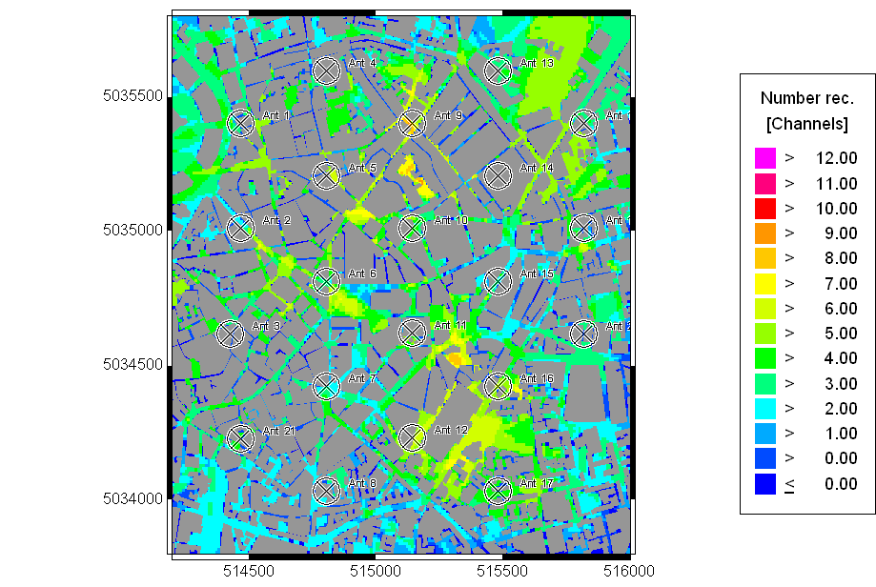
As we think, the available channels in the left down areas is increased by adding the antenna 21.

Conclusion
Moving the location of the antenna and adding more antennas will improve the system. When moving the location of the antenna, we should not move too far away from the previous location, because that will affect other antenna too much and lead to the unstable system. Adding more antennas will improve the system, but it will also increase the cost. Anyway, in this system, adding the antenna 21 is the reasonable choice because it makes the whole areas covered by better signal.

Improving the Co-Channel Interference by Changing the Locations and Height of Antennas

Setting Parameters
Base on the previous improvement, I want to decrease the co-channel interference in the centre area. In order to do that, I decide to move the antenna 15 towards the area where co-channel interference is poor. So I move the antenna to the location (x=515411.27, y=5034842.26), that also leads to the height of antenna increases from 34m to 45m.

Analysing Results
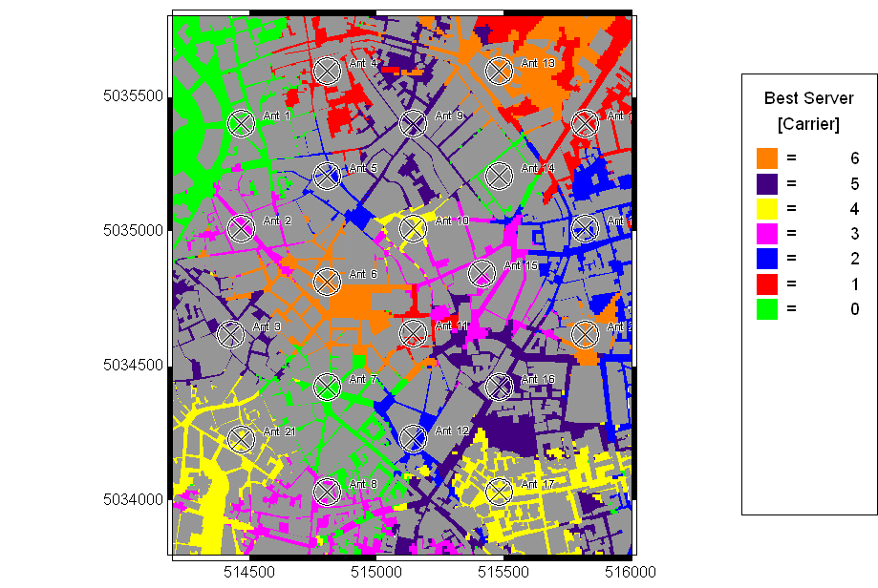
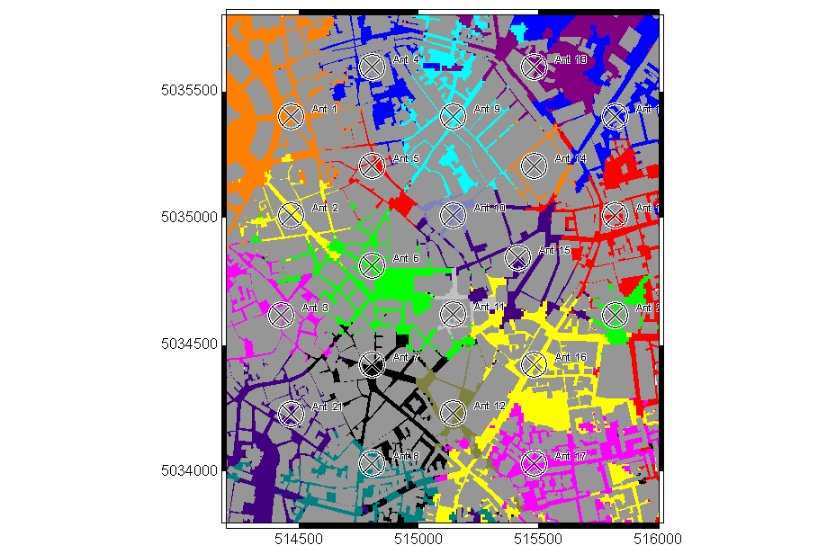
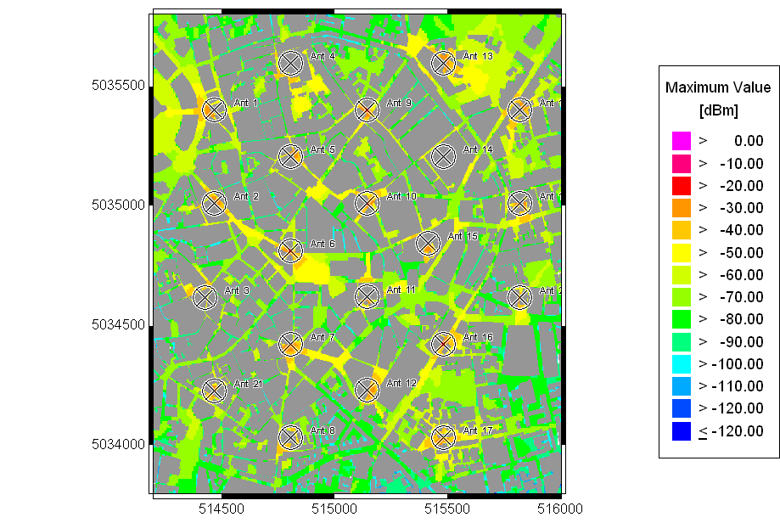
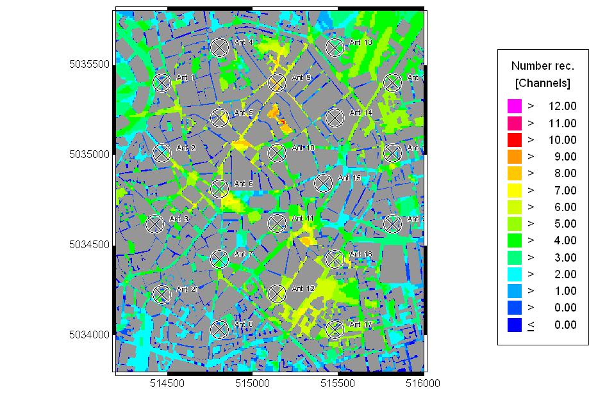
Through the pictures above, we can see that moving antenna 15 does bring bad effects to the system.
Because our aim is to reduce the co-channel interference in the area, we get the CoChannel Interference graph below.
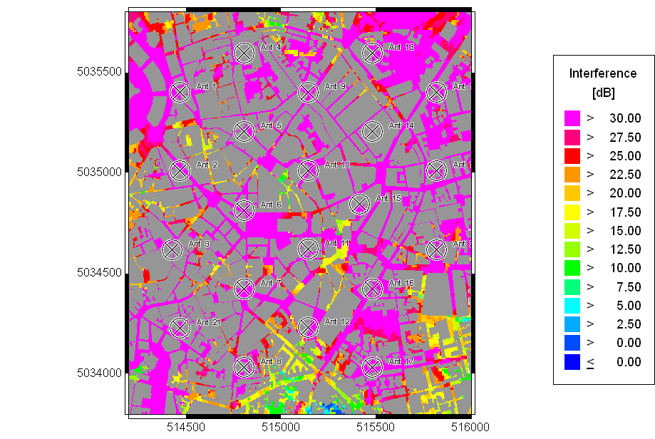
We can see that the co-channel interference is decreased (The centre blue region has disappeared). However, there is a blue area appearing at the centre bottom region. We should do further improvement to deal with that.

Conclusion
Trough changing the location and height of the antennas, we can reduce the co-channel interference. However, there may be more than one antenna which should be modified. With the changing of the location and height, we can get a reasonable distribution of antenna.

Improving the System to Minimise the Co-channel Interference

Setting Parameters
We use the same method as above to decrease the co-channel interference at the centre bottom area. We move the antenna 17 to the location (x=515424.35, y=5033967.49) with height 20m.

Analysing Results
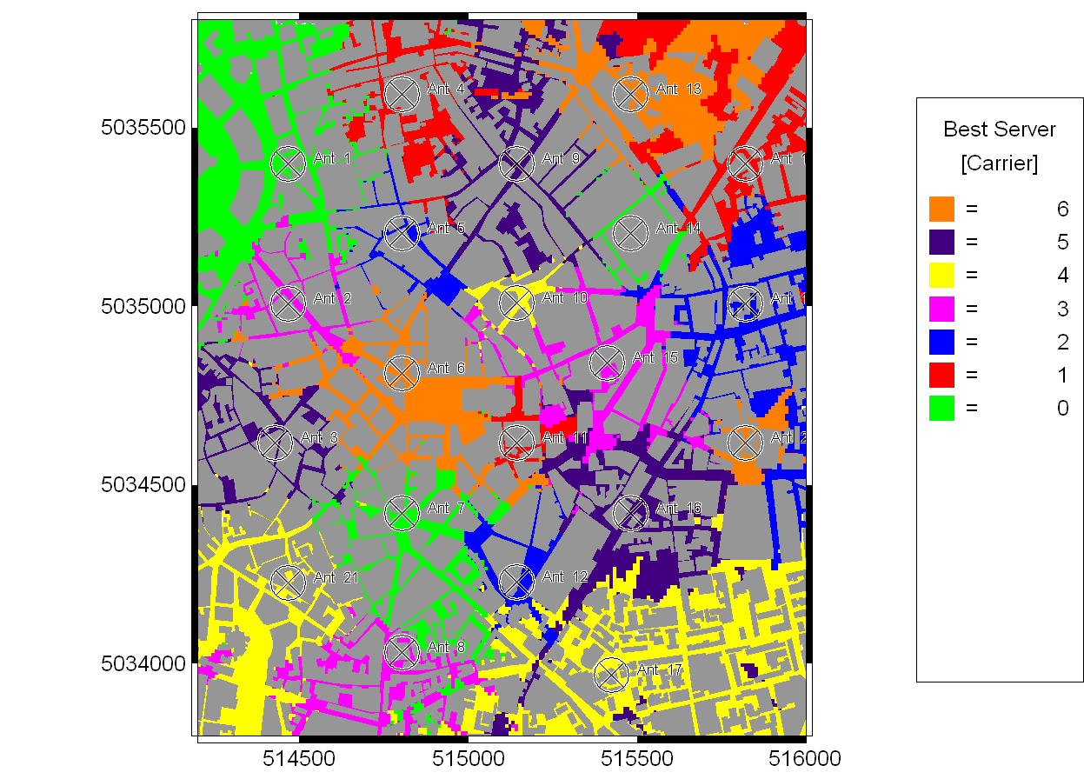
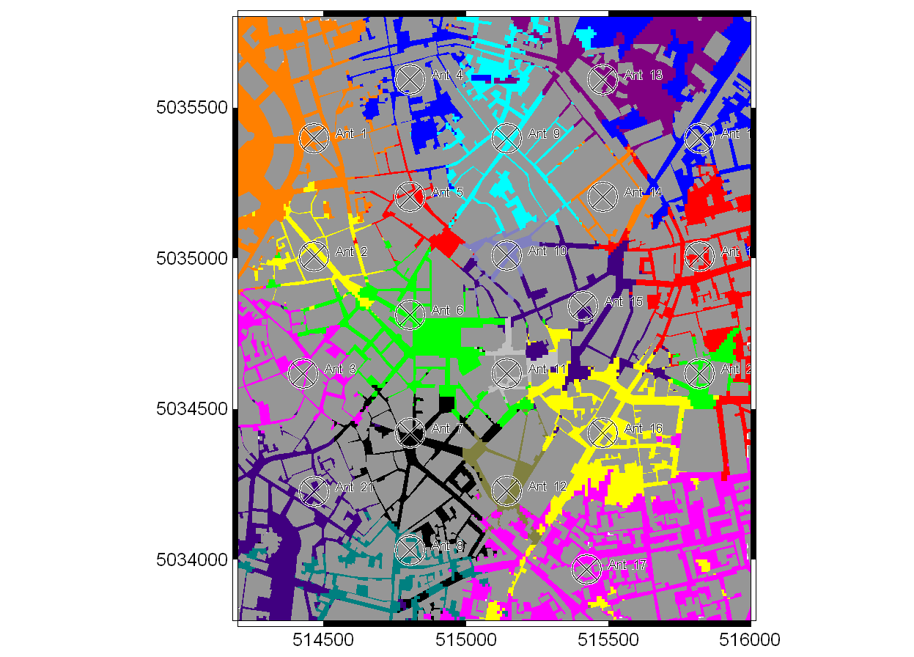
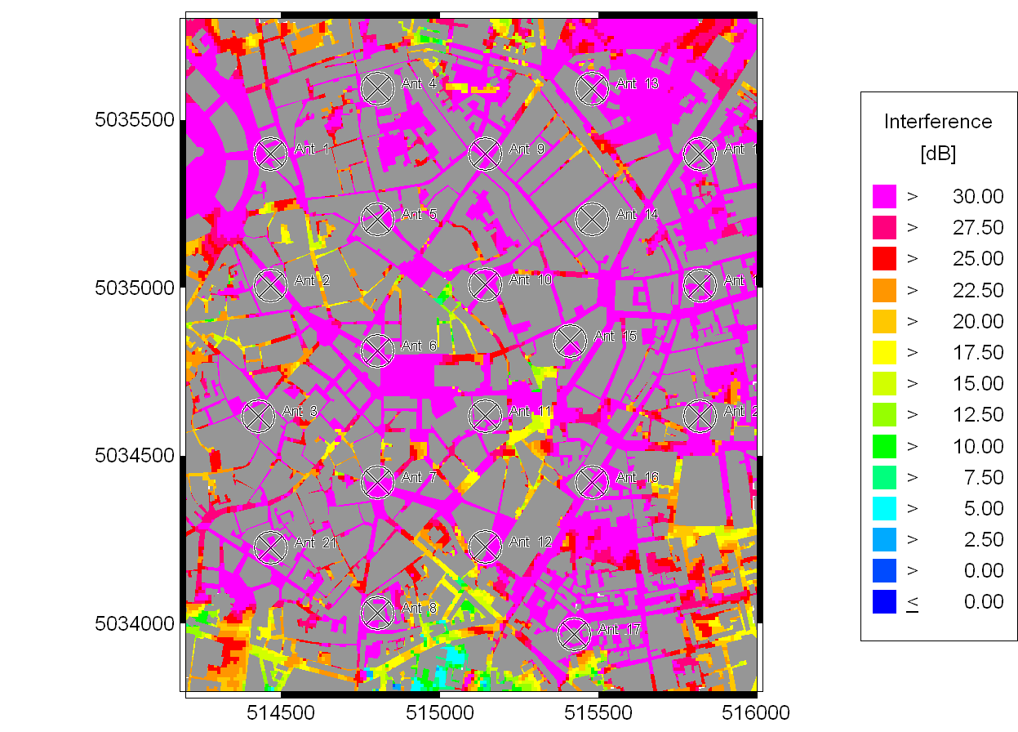
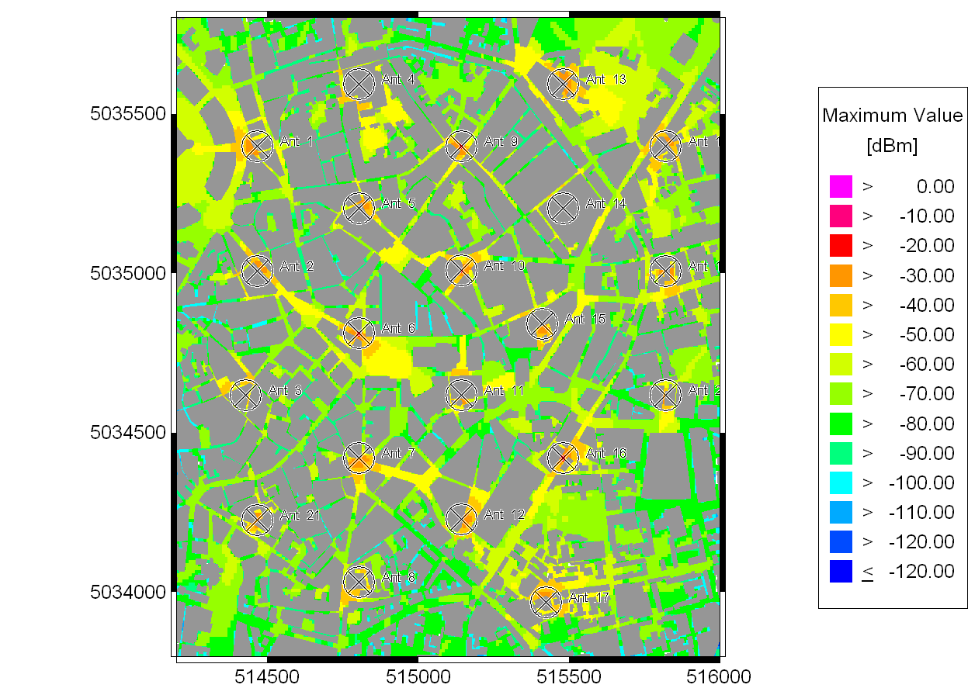
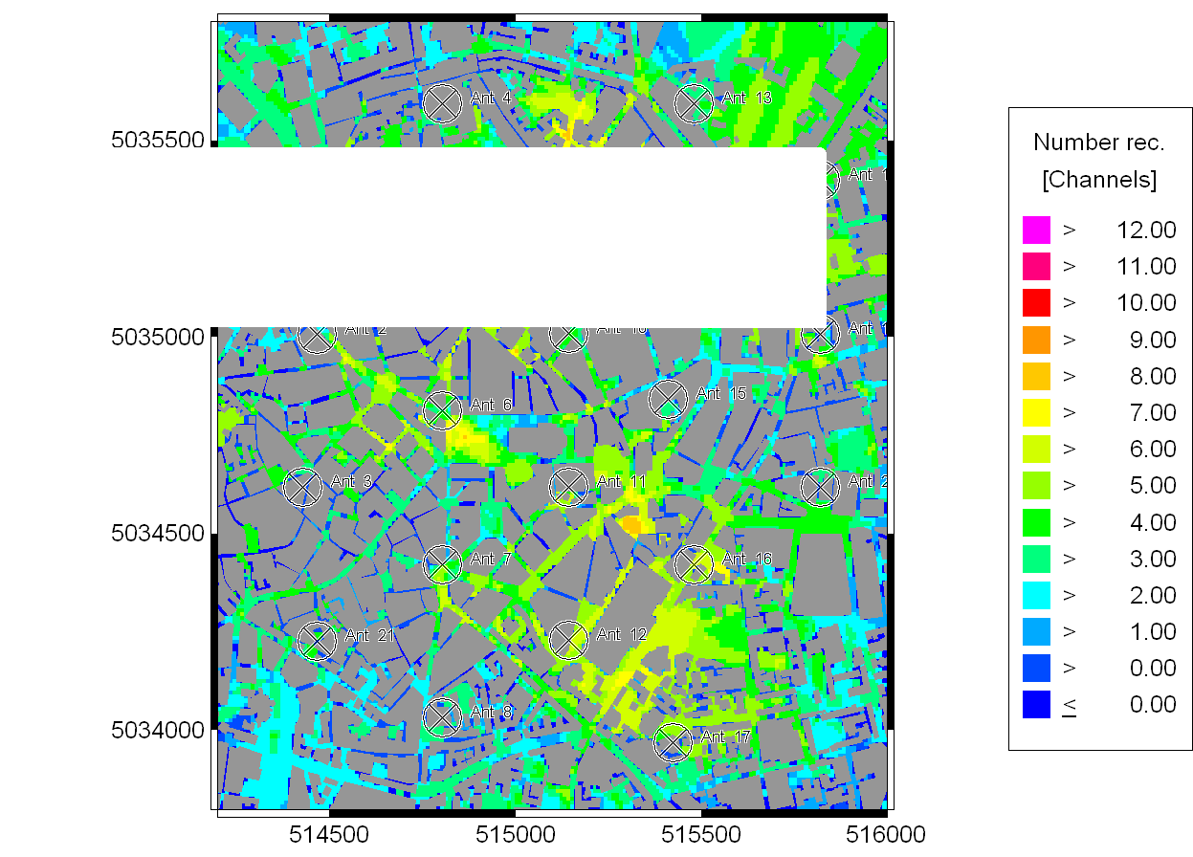

Conclusion
We can see that the co-channel interference in the centre bottom area is getter better, so the co-channel interference has been minimized. And the mobile telephone system is improved reasonably.

Discussion

Fading
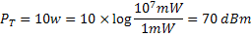
Through matlab with cost231hata.m, we use following code to calculate the loss.
cost231hata (1800, 30, 1.5, 0.2257, 1)
So
Because the standard deviation of fading is
So through the coverage.m
coverage (40, 10)
We can get the outage probability at the boundary of the cell

Co-channel Interference
The co-channel interference is

Conclusion
So in this mobile system of this area, we use 21 antennas with the distribution as the graph above. The power of transmitter is 10w. And the antennas are omni-directional.
Designing a mobile telephone system is work which should consider a lot of parameters. In order to do this well, we must investigate the background information of the city, such as the population, buildings, traffic system and so on. We also need to choose suitable frequency reuse patterns, types of antennas and size of the cell by calculations. Furthermore, we should also consider the potential changes in future. Thus, the layout of the mobile telephone system is complicated and must be treated very carefully.

References
Introduction to Wireless Systems, P. Mohana Shankar, John Wiley & Sons, New York, 2002. ISBN 0-471-32167-2

